Calculating pylint score

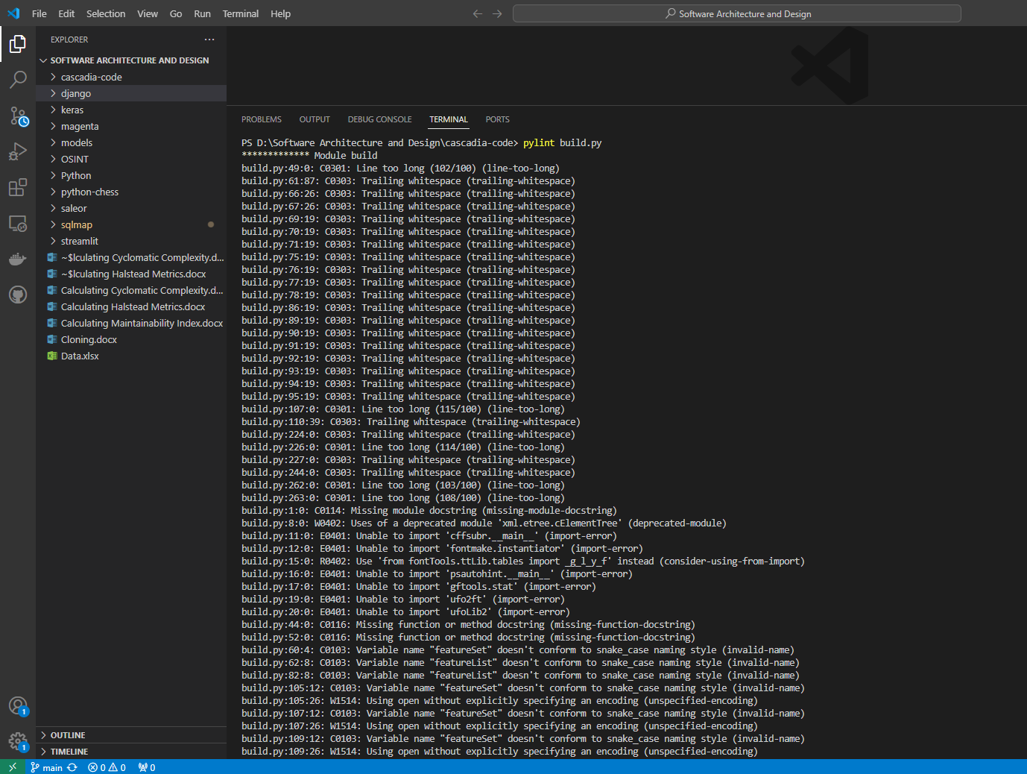

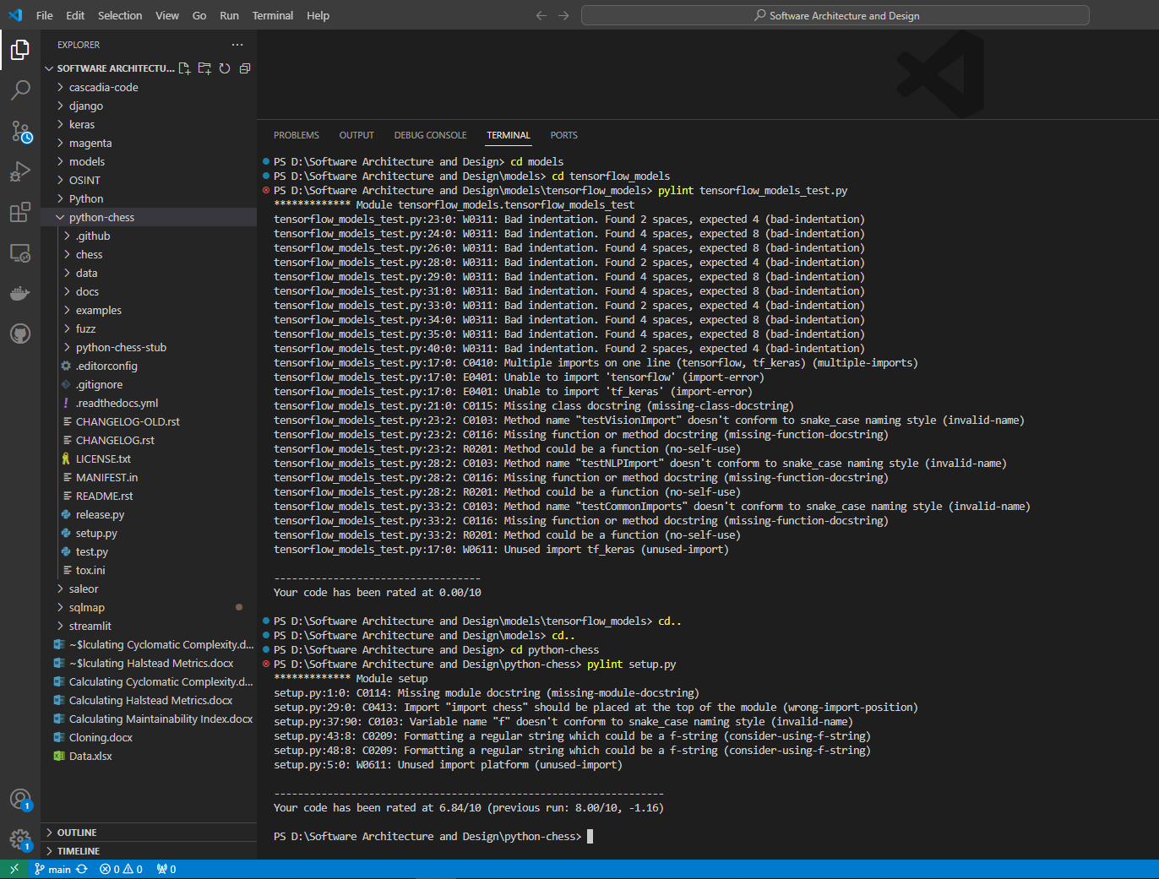

PS D:\Software Architecture and Design\cascadia-code> pylint build.py

************* Module build

build.py:49:0: C0301: Line too long (102/100) (line-too-long)

build.py:61:87: C0303: Trailing whitespace (trailing-whitespace)

build.py:66:26: C0303: Trailing whitespace (trailing-whitespace)

build.py:67:26: C0303: Trailing whitespace (trailing-whitespace)

build.py:69:19: C0303: Trailing whitespace (trailing-whitespace)

build.py:70:19: C0303: Trailing whitespace (trailing-whitespace)

build.py:71:19: C0303: Trailing whitespace (trailing-whitespace)

build.py:75:19: C0303: Trailing whitespace (trailing-whitespace)

build.py:76:19: C0303: Trailing whitespace (trailing-whitespace)

build.py:77:19: C0303: Trailing whitespace (trailing-whitespace)

build.py:78:19: C0303: Trailing whitespace (trailing-whitespace)

build.py:86:19: C0303: Trailing whitespace (trailing-whitespace)

build.py:89:19: C0303: Trailing whitespace (trailing-whitespace)

build.py:90:19: C0303: Trailing whitespace (trailing-whitespace)

build.py:91:19: C0303: Trailing whitespace (trailing-whitespace)

build.py:92:19: C0303: Trailing whitespace (trailing-whitespace)

build.py:93:19: C0303: Trailing whitespace (trailing-whitespace)

build.py:94:19: C0303: Trailing whitespace (trailing-whitespace)

build.py:95:19: C0303: Trailing whitespace (trailing-whitespace)

build.py:107:0: C0301: Line too long (115/100) (line-too-long)

build.py:110:39: C0303: Trailing whitespace (trailing-whitespace)

build.py:224:0: C0303: Trailing whitespace (trailing-whitespace)

build.py:226:0: C0301: Line too long (114/100) (line-too-long)

build.py:227:0: C0303: Trailing whitespace (trailing-whitespace)

build.py:244:0: C0303: Trailing whitespace (trailing-whitespace)

build.py:262:0: C0301: Line too long (103/100) (line-too-long)

build.py:263:0: C0301: Line too long (108/100) (line-too-long)

build.py:1:0: C0114: Missing module docstring (missing-module-docstring)

build.py:8:0: W0402: Uses of a deprecated module 'xml.etree.cElementTree' (deprecated-module)

build.py:11:0: E0401: Unable to import 'cffsubr.__main__' (import-error)

build.py:12:0: E0401: Unable to import 'fontmake.instantiator' (import-error)

build.py:15:0: R0402: Use 'from fontTools.ttLib.tables import _g_l_y_f' instead (consider-using-from-import)

build.py:16:0: E0401: Unable to import 'psautohint.__main__' (import-error)

build.py:17:0: E0401: Unable to import 'gftools.stat' (import-error)

build.py:19:0: E0401: Unable to import 'ufo2ft' (import-error)

build.py:20:0: E0401: Unable to import 'ufoLib2' (import-error)

build.py:21:0: E0401: Unable to import 'vttLib' (import-error)

build.py:22:0: E0401: Unable to import 'vttLib.transfer' (import-error)

build.py:23:0: E0401: Unable to import 'vttmisc' (import-error)

build.py:44:0: C0116: Missing function or method docstring (missing-function-docstring)

build.py:52:0: C0116: Missing function or method docstring (missing-function-docstring)

build.py:59:0: C0116: Missing function or method docstring (missing-function-docstring)

build.py:60:4: C0103: Variable name "featureSet" doesn't conform to snake_case naming style (invalid-name)

build.py:62:8: C0103: Variable name "featureList" doesn't conform to snake_case naming style (invalid-name)

build.py:82:8: C0103: Variable name "featureList" doesn't conform to snake_case naming style (invalid-name)

build.py:105:12: C0103: Variable name "featureSet" doesn't conform to snake_case naming style (invalid-name)

build.py:105:26: W1514: Using open without explicitly specifying an encoding (unspecified-encoding)

build.py:107:12: C0103: Variable name "featureSet" doesn't conform to snake_case naming style (invalid-name)

build.py:107:26: W1514: Using open without explicitly specifying an encoding (unspecified-encoding)

build.py:109:12: C0103: Variable name "featureSet" doesn't conform to snake_case naming style (invalid-name)

build.py:109:26: W1514: Using open without explicitly specifying an encoding (unspecified-encoding)

build.py:113:0: C0103: Function name "set_font_metaData" doesn't conform to snake_case naming style (invalid-name)

build.py:113:0: C0116: Missing function or method docstring (missing-function-docstring)

build.py:113:22: W0621: Redefining name 'font' from outer scope (line 579) (redefined-outer-name)

build.py:135:0: C0116: Missing function or method docstring (missing-function-docstring)

build.py:146:0: C0116: Missing function or method docstring (missing-function-docstring)

build.py:147:4: W0621: Redefining name 'designspace' from outer scope (line 362) (redefined-outer-name)

build.py:181:0: C0116: Missing function or method docstring (missing-function-docstring)

build.py:183:4: W0621: Redefining name 'font' from outer scope (line 579) (redefined-outer-name)

build.py:192:0: C0116: Missing function or method docstring (missing-function-docstring)

build.py:193:4: W0621: Redefining name 'designspace' from outer scope (line 362) (redefined-outer-name)

build.py:201:0: C0116: Missing function or method docstring (missing-function-docstring)

build.py:202:4: W0621: Redefining name 'designspace' from outer scope (line 362) (redefined-outer-name)

build.py:203:4: W0621: Redefining name 'instance_descriptor' from outer scope (line 475) (redefined-outer-name)

build.py:220:0: C0116: Missing function or method docstring (missing-function-docstring)

build.py:221:4: W0621: Redefining name 'designspace' from outer scope (line 362) (redefined-outer-name)

build.py:228:4: C0103: Variable name "familyName" doesn't conform to snake_case naming style (invalid-name)

build.py:229:4: C0103: Variable name "styleName" doesn't conform to snake_case naming style (invalid-name)

build.py:236:4: C0103: Variable name "varFont" doesn't conform to snake_case naming style (invalid-name)

build.py:253:8: W0107: Unnecessary pass statement (unnecessary-pass)

build.py:277:0: C0116: Missing function or method docstring (missing-function-docstring)

build.py:313:0: C0116: Missing function or method docstring (missing-function-docstring)

build.py:323:0: C0116: Missing function or method docstring (missing-function-docstring)

build.py:575:9: W1514: Using open without explicitly specifying an encoding (unspecified-encoding)

build.py:598:15: W0703: Catching too general exception Exception (broad-except)

build.py:586:19: R1732: Consider using 'with' for resource-allocating operations (consider-using-with)

build.py:603:15: R1732: Consider using 'with' for resource-allocating operations (consider-using-with)

build.py:8:0: W0611: Unused xml.etree.cElementTree imported as ET (unused-import)

build.py:9:0: W0611: Unused import tempfile (unused-import)

build.py:23:0: W0611: Unused tsic imported from vttmisc (unused-import)

-----------------------------------

Your code has been rated at 5.52/10

PS D:\Software Architecture and Design\django> pylint setup.py

************* Module setup

setup.py:1:0: C0114: Missing module docstring (missing-module-docstring)

setup.py:4:0: W0402: Uses of a deprecated module 'distutils.sysconfig' (deprecated-module)

setup.py:15:0: C0103: Constant name "overlay_warning" doesn't conform to UPPER_CASE naming style (invalid-name)

setup.py:27:12: C0103: Constant name "overlay_warning" doesn't conform to UPPER_CASE naming style (invalid-name)

setup.py:36:8: C0209: Formatting a regular string which could be a f-string (consider-using-f-string)

------------------------------------------------------------------

Your code has been rated at 7.37/10 (previous run: 8.75/10, -1.38)

PS D:\Software Architecture and Design\keras> pylint setup.py

************* Module setup

setup.py:10:0: C0116: Missing function or method docstring (missing-function-docstring)

setup.py:12:9: W1514: Using open without explicitly specifying an encoding (unspecified-encoding)

setup.py:12:47: C0103: Variable name "fp" doesn't conform to snake_case naming style (invalid-name)

setup.py:16:0: C0116: Missing function or method docstring (missing-function-docstring)

------------------------------------------------------------------

Your code has been rated at 8.00/10 (previous run: 7.37/10, +0.63)

PS D:\Software Architecture and Design\models\tensorflow_models> pylint tensorflow_models_test.py

************* Module tensorflow_models.tensorflow_models_test

tensorflow_models_test.py:23:0: W0311: Bad indentation. Found 2 spaces, expected 4 (bad-indentation)

tensorflow_models_test.py:24:0: W0311: Bad indentation. Found 4 spaces, expected 8 (bad-indentation)

tensorflow_models_test.py:26:0: W0311: Bad indentation. Found 4 spaces, expected 8 (bad-indentation)

tensorflow_models_test.py:28:0: W0311: Bad indentation. Found 2 spaces, expected 4 (bad-indentation)

tensorflow_models_test.py:29:0: W0311: Bad indentation. Found 4 spaces, expected 8 (bad-indentation)

tensorflow_models_test.py:31:0: W0311: Bad indentation. Found 4 spaces, expected 8 (bad-indentation)

tensorflow_models_test.py:33:0: W0311: Bad indentation. Found 2 spaces, expected 4 (bad-indentation)

tensorflow_models_test.py:34:0: W0311: Bad indentation. Found 4 spaces, expected 8 (bad-indentation)

tensorflow_models_test.py:35:0: W0311: Bad indentation. Found 4 spaces, expected 8 (bad-indentation)

tensorflow_models_test.py:40:0: W0311: Bad indentation. Found 2 spaces, expected 4 (bad-indentation)

tensorflow_models_test.py:17:0: C0410: Multiple imports on one line (tensorflow, tf_keras) (multiple-imports)

tensorflow_models_test.py:17:0: E0401: Unable to import 'tensorflow' (import-error)

tensorflow_models_test.py:17:0: E0401: Unable to import 'tf_keras' (import-error)

tensorflow_models_test.py:21:0: C0115: Missing class docstring (missing-class-docstring)

tensorflow_models_test.py:23:2: C0103: Method name "testVisionImport" doesn't conform to snake_case naming style (invalid-name)

tensorflow_models_test.py:23:2: C0116: Missing function or method docstring (missing-function-docstring)

tensorflow_models_test.py:23:2: R0201: Method could be a function (no-self-use)

tensorflow_models_test.py:28:2: C0103: Method name "testNLPImport" doesn't conform to snake_case naming style (invalid-name)

tensorflow_models_test.py:28:2: C0116: Missing function or method docstring (missing-function-docstring)

tensorflow_models_test.py:28:2: R0201: Method could be a function (no-self-use)

tensorflow_models_test.py:33:2: C0103: Method name "testCommonImports" doesn't conform to snake_case naming style (invalid-name)

tensorflow_models_test.py:33:2: C0116: Missing function or method docstring (missing-function-docstring)

tensorflow_models_test.py:33:2: R0201: Method could be a function (no-self-use)

tensorflow_models_test.py:17:0: W0611: Unused import tf_keras (unused-import)

-----------------------------------

Your code has been rated at 0.00/10

PS D:\Software Architecture and Design\python-chess> pylint setup.py

************* Module setup

setup.py:1:0: C0114: Missing module docstring (missing-module-docstring)

setup.py:29:0: C0413: Import "import chess" should be placed at the top of the module (wrong-import-position)

setup.py:37:90: C0103: Variable name "f" doesn't conform to snake_case naming style (invalid-name)

setup.py:43:8: C0209: Formatting a regular string which could be a f-string (consider-using-f-string)

setup.py:48:8: C0209: Formatting a regular string which could be a f-string (consider-using-f-string)

setup.py:5:0: W0611: Unused import platform (unused-import)

------------------------------------------------------------------

Your code has been rated at 6.84/10 (previous run: 8.00/10, -1.16)

PS D:\Software Architecture and Design\saleor> pylint manage.py

************* Module manage

manage.py:1:0: C0114: Missing module docstring (missing-module-docstring)

manage.py:8:4: E0401: Unable to import 'django.core.management' (import-error)

-----------------------------------

Your code has been rated at 0.00/10

PS D:\Software Architecture and Design\sqlmap> pylint sqlmap.py

************* Module sqlmap

sqlmap.py:97: [E0601(used-before-assignment), ] Using variable 'logger' before assignment

-----------------------------------

Your code has been rated at 9.90/10